[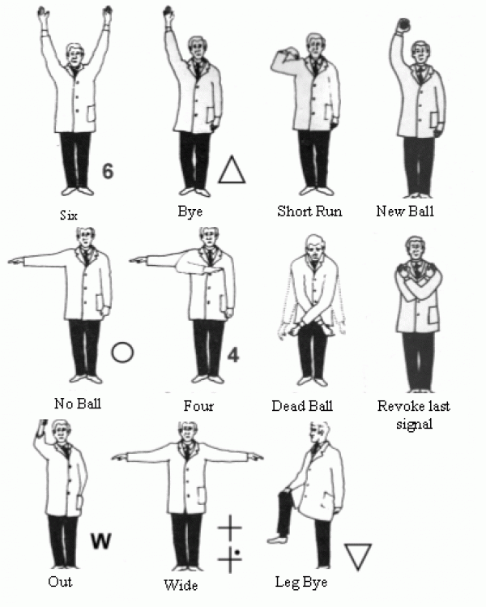](https://www.google.com/url?sa=i&rct=j&q=&esrc=s&source=images&cd=&cad=rja&uact=8&ved=2ahUKEwj956-606neAhVFhRoKHZuSDRcQjRx6BAgBEAU&url=http://www.pitchero.com/clubs/bransgorecricketclub/news/umpire-signals-and-scoring-symbols-340231.html&psig=AOvVaw0BY52O8mZc1j960niUWcur&ust=1540833622519243)