[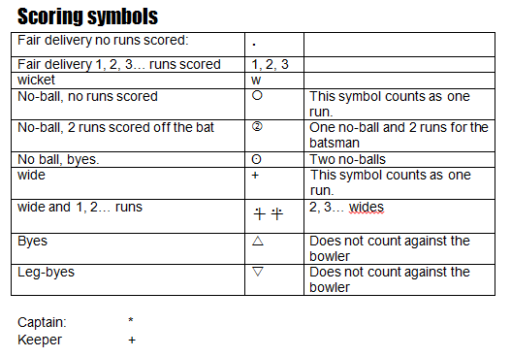](https://images.google.com/url?sa=i&rct=j&q=&esrc=s&source=imgres&cd=&cad=rja&uact=8&ved=2ahUKEwi-gLPn0aneAhWjyYUKHc1PBvsQjRx6BAgBEAU&url=https%3A%2F%2Fwww.cricketswitzerland.ch%2Fnews%2F2014%2F2014-scoring-symbols%2F&psig=AOvVaw2gANI4ZiFAOLxtN1R_QZWl&ust=1540833058962829)

[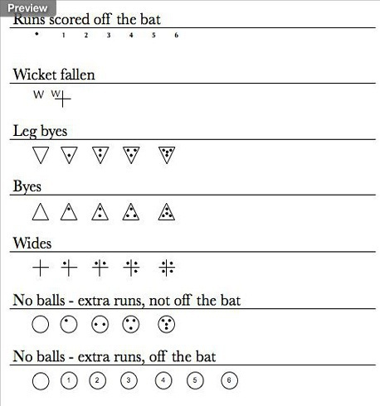](https://images.google.com/url?sa=i&rct=j&q=&esrc=s&source=imgres&cd=&cad=rja&uact=8&ved=2ahUKEwiu7tKA0qneAhUL2BoKHZlTCg0QjRx6BAgBEAU&url=http%3A%2F%2Faxminstertowncricketclub.co.uk%2Fumpires-scorers%2F&psig=AOvVaw2gANI4ZiFAOLxtN1R_QZWl&ust=1540833058962829)